|  |  |  |  |  |  |  |  |  |  |  |  |
| --- | --- | --- | --- | --- | --- | --- | --- | --- | --- | --- | --- |
| |  | | --- | |  | | **DOCUMENT MANAGEMENT PROCEDURE** | | |  |  | | --- | --- | | **Security Level** | **: Non-Confidential** | | **Document No** | **: GAC-SOP-001** | | **Revision No** | **: 00** | | **Revision Date** | **: 2025. 03. 28.** |   **GA & Contract Department**  **Vung Ang II Thermal Power LLC** | |

|  |  |  |  |  |  |  |
| --- | --- | --- | --- | --- | --- | --- |
| **Revision History** | | | | | | |
| **No** | **Reason of Revision** | **Prepare** | **Review** | **Confirm** | **Approve** | **Approval Date** |
| 0 | Enactment  of  Procedure | D.T.Q. Diep  (GPL) | K.H Min  (GACM) |  | J.S Lim  (SGM) | 2025.03.28 |
|  |
| 1 |  |  |  |  |  |  |
| 2 |  |  |  |  |  |  |

Table of contents

PART 1 GENERAL PROVISION 5

1.1 PREFACE 5

1.2 DEFINITION 5

1.3 PURPOSE OF PROCEDURE 9

1.4 SCOPE OF APPLICATION 9

1.5 COPYRIGHT STATEMENT 9

PART 2 DOCUMENTATION 10

2.1 DOCUMENT FORMATTING 10

2.1.1 General Principles 10

2.1.2 Operational Document 12

2.1.3 Outgoing Correspondence 14

2.1.4 Decision 16

2.1.5 Power of Attorney (POA) 17

2.1.6 Other Templates 18

2.2 COMPANY SEAL 18

2.2.1 Seal Management 18

PART 3 DOCUMENT MANAGEMENT 20

3.1 CONFIDENTIAL DOCUMENT 20

3.1.1 Classification 20

3.1.2 Access Control 20

3.1.3 Storage and Protection 20

3.1.4 Retrieving and Borrowing 20

3.1.5 Disposal and Destruction 21

3.2 NON-CONFIDENTIAL DOCUMENT 21

3.2.1 Classification 21

3.2.2 Receiving and Distribution/ Recording and Dispatch 21

3.2.3 Storage 23

3.2.4 Retrieving and Borrowing 24

3.2.5 Disposal and Destruction 24

[ANNEX 1] CORRESPONDENCE NUMBER CODING 26

[ANNEX 2] INTERNAL DOCUMENT NUMBER / FILE NAME CODING 30

[ANNEX 3] TEMPLATES 34

[ANNEX 4] ABBREVIATION OF O&M OFFICE 39

GENERAL PROVISION

PREFACE

This Document Management Procedure is established to support the process of composing, text editing, consistently compiling and managing Documents according to an available and certain standard in documentation office use. However, within the limits of this Procedure, it cannot represent all situations and cover all problems that may occur. Therefore, equipping with certain related knowledge and understanding as well as a sense of honesty, and high responsibility of each User and PIC is the most important thing in operating Document management properly. This Procedure may be amended from time to time if required.

In addition to this Procedure, subsequent policies, notices, rules, and regulations… (in writing) of the Company will be considered as official information with the same effect as this Procedure and are inseparable parts of the Procedure.

DEFINITION

|  |  |  |
| --- | --- | --- |
| * BOD | : | refers to Board of Directors which includes General Director, Project Director, Station General Manager, Chief Finance Officer, Operation Director, Mantenance Director, and others. |
| * Company | : | refers to Vung Ang II Thermal Power LLC. |
| * Confidential Documents | : | refers to Documents that are restricted, secret, classified, private and personal. Copying and distribution of these Documents needs careful handling to preserve the sensitive information it contains. Respective Department Manager shall classify confidential Documents. |
| * Correspondences | : | refers to Documents that are used as medium of communication (e.g. Letters/Transmittal, Fax, E-mails, and Memorandum). |
| * DC | : | refers to Document Controller who is an individual responsible for managing the creation, storage, retrieval, distribution, and tracking of Documents within the Company. |
| * Document | : | refers to a written, printed, or electronic piece of information that provides evidence, serves as a record, or communicates some form of data, message, or content in the Company. |
| * Document Numbering | : | refers to a systematic method of assigning unique identifiers to Document to ensure proper organization, retrieval, revision control, and traceability. It is typically presented in the cover page or at the upper right side of the Document. (e.g. Letters/Transmittal Numbering and Basic Internal Document Numbering) |
| * DMA | : | refers to the Document Management Administrator who is responsible for Document handling, registration, and distribution within a Division. Each Division typically assigns one or two DMA(s). |
| * DSR | : | refers to the Document Storage Room which is designated area or space within the Company specifically intended for the organized storage, maintenance, and retrieval of physical Documents and records. |
| * EADMS | : | refers to Electronic Approval & Document Management System which is a digital platform designed to streamline the process of reviewing, approving, storing, organizing, managing and tracking Documents within the Company. It allows users to create, submit, approve, track, control revision and access, retrieve electronically, eliminating the need for physical paperwork and manual approvals. It ensures streamlined Document workflows and regulatory compliance. |
| * File Numbering | : | refers to the practice of assigning numerical identifiers to electronic files in a systematic manner for the Company’s common server purpose. It includes additional information such as the file title, editing date, revision information and language details in addition to the Document Number. |
| * Folder Numbering | : | refers to the process of assigning numerical identifiers to folders or directories in a systematic manner for the folder structure of the Company’s common server and the physical Document storage of the DSR. |
| * HO | : | refers to Hanoi Office. |
| * IA | : | refers to Internal Auditor (if applicable) who is the individual or authorized personnel of the Company tasked to initially confirm PR before approval of authorities as provided in this Procedure. |
| * Internal Document | : | refers to any Document that is created, used, and circulated within the Company for operational, administrative, technical, or managerial purposes. It is not intended for external distribution unless explicitly authorized. Practically, it refers to all Documents except Incoming/ Outgoing Correspondence and includes, but are not limited to policies, procedures, guidelines, meeting minutes, internal reports, Technical Documents, manuals, and internal memos. |
| * Management Delegation | : | refers to the Management Delegation which indicates the order or schedule that establishes the authority to approve all internal decisions or procurement transactions at different threshold amounts. |
| * Master Outgoing Log | : | refers to a comprehensive record or Document used to track and manage the outgoing Documents within the Company which contains detailed information about each outgoing Document, including the date and time of dispatch, recipient information, Document No., brief description, or contents of the Document. It can be extracted from EADMS. |
| * Master Receiving Log | : | refers to a comprehensive record or Document used to track and manage the receipt of various Documents within the Company which contains detailed information about each received document, including the date and time of receipt, sender, Document No., brief description, or contents of the Document. It can be extracted from EADMS. |
| * O&M | : | refers to Operation & Maintenance. |
| * PIC (or DIC) | : | refers to Person (Department) in Charge who is the person (Department) appointed to maintain control of the issue, amendment, and withdrawal of documentation. It will be assigned by the BOD during the Document distribution process via EADMS. |
| * Procedure | : | refers to this Document Management Procedure which recommends or instructs how to manage and control Document. |
| * Quality Records | : | refers to records furnished Documentary evidence of the quality of items and of activities affecting quality. In this Procedure, a Document is considered a quality assurance record when it has been completed, verified (if applicable) and signed by the approving authority. |
| * Sender | : | refers to the person who signs the Outgoing Correspondence, taking responsibility and issuing the document under their name. |
| * SO | : | refers to the Site Office. |
| * SOP(s) | : | refers to a Document that provides detailed instructions on how to perform specific tasks or procedures step-by-step to ensure consistency and efficiency in work processes, usually applied to repetitive and standardized tasks. |
| * Technical Documents | : | refers to Technical Reports, Procedures, Manuals, Drawings, Technical Specifications, Technical Bulletins, Design Specifications, Standards and Operating/Maintenance Instructions. |
| * TOC | : | refers to Table of Contents which provides an overview of the Document’s contents by listing the subjects of each sub-item. |
| * Transmittal Form | : | refers to a Document used to accompany Documents being sent from the Company to external entities. It serves as a cover sheet or letter that provides essential information about the enclosed Documents and the intended recipient. |
| * User | : | refers to an individual that interacts with Documents as part of their activities, tasks, or responsibilities. It mainly includes employees who create, edit, review, retrieve, copy, or share Documents as a part of their job responsibilities. |

PURPOSE OF PROCEDURE

The purpose of the Procedure is to provide a structured and systematic Document management system for the effective creation, issue, approval or removal of all kinds of Documents of the Company.

The Company shall establish a system for receipt, control, distribution and maintenance not only of the Correspondences but also of Basic Internal Documents. Its purpose is to provide a systematic flow of handling and processing Documents.

Adherence to this Procedure will ensure all personnel always have easy access to the current and most up-to-date Documents they need to perform their work.

## 

SCOPE OF APPLICATION

This Procedure shall be applicable to all Documents received, generated, and transmitted by and for the Company.

This Procedure applies to all Users creating, reviewing, authorizing, issuing, and removing Documents at O&M, excluding individual personal document. It also applies to DC and PIC who are responsible for keeping records.

The Procedure applies to all O&M Documents and includes but is not limited to the following:

Management Documents such as: SOPs, guidelines, procedures, regulations, rules, notifications…

Company dispatches such as: Correspondences, Reports, Plans, Official Dispatches, Proposals, Decisions, Memorandum of Understanding, Cooperation Minutes, Contracts…

Departmental Documents such as: Internal Minutes, Handover Minutes, internal management Document forms/templates and all other kinds of official Documents…

Engineering blueprint & Technical Documents: drawings, standards, functional specifications…

COPYRIGHT STATEMENT

The Company reserves all rights over this Procedure and its contents. Any part of this Procedure should be treated as confidential and not be disclosed or distributed, copied, reproduced, or amended for any reason without prior written permission of the Company.

DOCUMENTATION

DOCUMENT FORMATTING

All employees must comply with the following regulations when drafting Documents and make full use of the form templates shared through EADMS to ensure standardized document creation. The template format defined below must not be modified arbitrarily. The editable file, which will continue to be added as needed, must be used through the path provided in ANNEX 3.

General Principles

Layout Margins

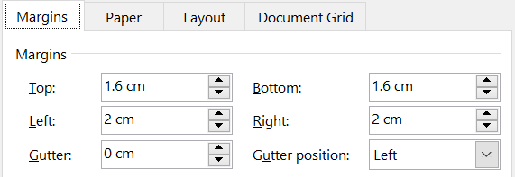

Header, Footer & Logo

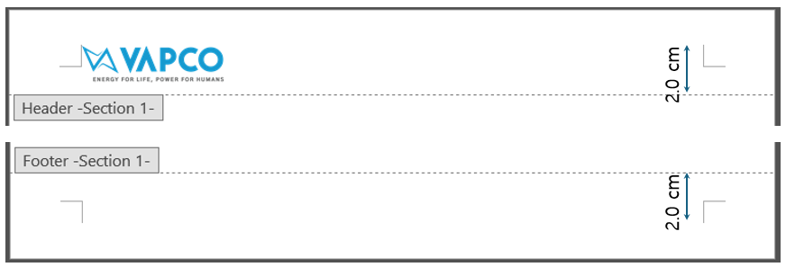

Unless otherwise specified in this Procedure, the Company's logo must be displayed in the top left corner of all official Documents of the Company with the following size and positioning.

* Size:

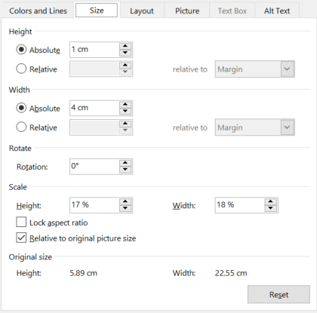

* Position:

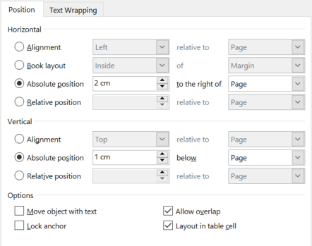

Font & Size

“Arial” font in size 12 is an official font and size to be used in all internally composed Documents in the Company.

Operational Document

An Operational document refers to various regulations, policies, guidelines, and SOPs necessary to systematically and uniformly control the Company operations.

Cover Page

The cover page must include:

* Document title in all bold capital letters in size 32,
* Security Level (Confidential/Non-confidential),
* Document Number,
* Revision Number,
* Revision Date in size 14 (bold), and
* Name of the issuing Department (or higher level) along with the full Company name in size 20 (bold).

Revision History

텍스트, 스크린샷, 번호, 폰트이(가) 표시된 사진

AI가 생성한 콘텐츠는 부정확할 수 있습니다.

From this page onward, until the end of main body, the following header board must be inserted at the top of each page.

텍스트, 스크린샷, 폰트, 라인이(가) 표시된 사진

AI가 생성한 콘텐츠는 부정확할 수 있습니다.

TOC

Documents longer than ten (10) pages require a TOC and title page. Short Documents do not require a TOC unless it adds value to the Document. The TOC should be on page two of the Document, immediately after the title page.

Main Body

* The main body uses the following seven levels of headings hierarchically.

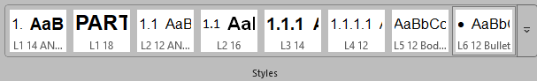

* Frequently used terms or those requiring clarification may be included in a separate Definitions section. In such cases, the defined terms should be listed in alphabetical order.
* When referring to other clauses within the document, cross-references in Captions function should be actively used to ensure consistency in references even after revisions.



* At the very end of the main body, “ANNEX TO THIS DOCUMENT” must be presented.

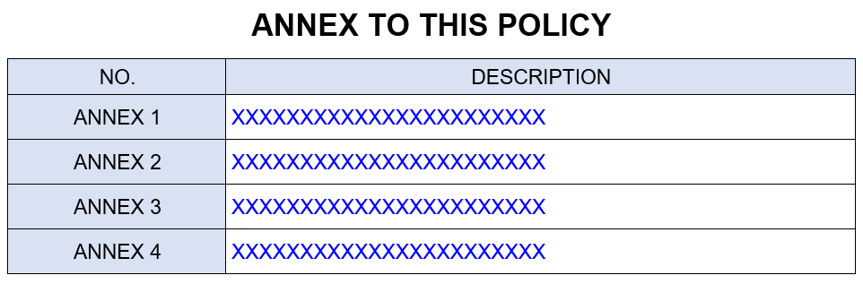

ANNEX

The ANNEX does not use a header board. Only the Company’s logo is displayed in the top left corner of the page, as specified in 2.1.1.2 General Principle.

Below it, "**[ANNEX XX]**" is written in bold, size 16.

Under this, the title of the ANNEX is written in bold, uppercase, size 16, and center aligned.

The main body of the ANNEX begins with the style L1 14 ANNEX, followed by L2 12 ANNEX, L5 12 Body Text, and L6 12 Bullet used hierarchically.

Outgoing Correspondence

Header, Footer, Logo and Address

* Position: Header from Top 1.0 cm / Footer from Bottom 1.5 cm

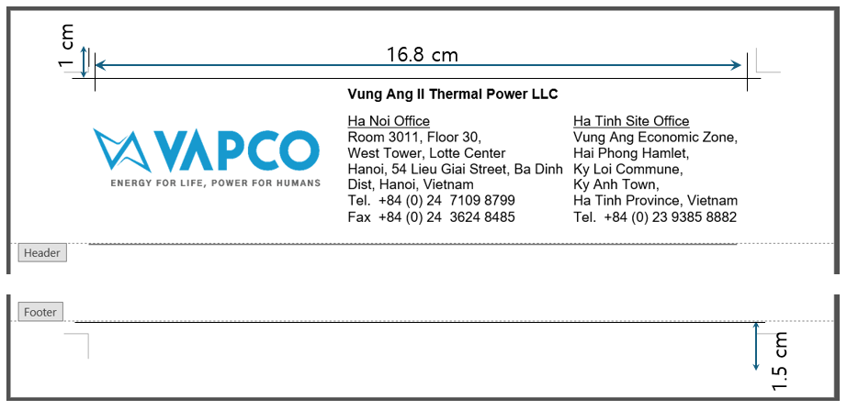

* Logo Position and Size

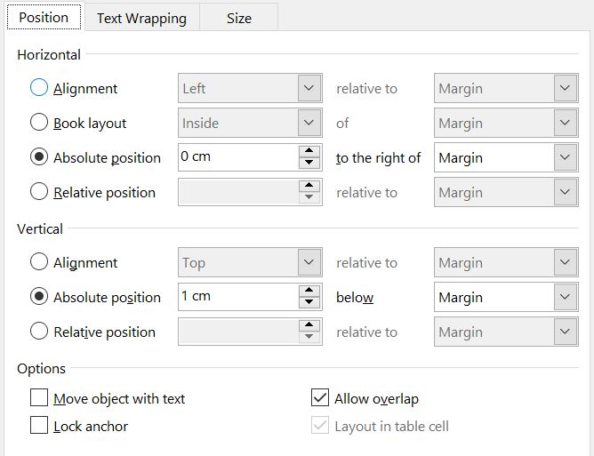

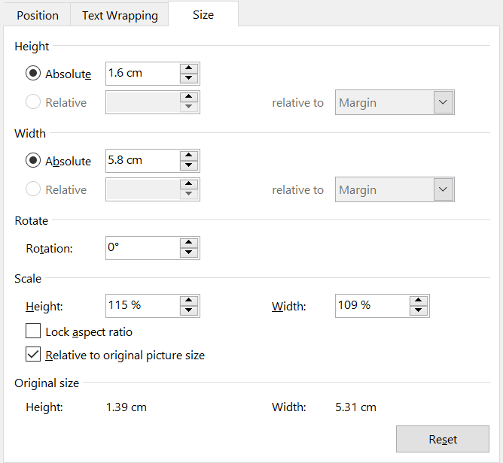

* Address Information

All text must be in size 10. The Company's full name should be in bold at the top. Below, the HO address and contact details should be on the left, while the SO address and contact details should be on the right.

Reference Section

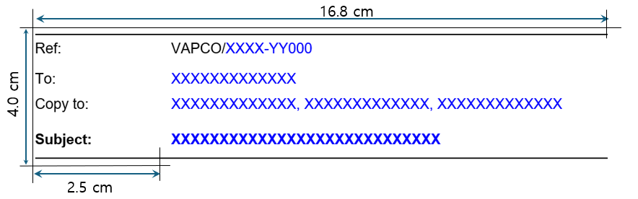

All text must be in size 12.

The reference number is assigned according to the Outgoing Correspondence Number Coding in 1.1 of ANNEX 1, following the format: "VAPCO/**[**Recipient Company**]**-**[**Year**][**Serial Number**]**."

"To" should include the recipient, while "Copy to" should list the relevant parties for reference.

The “Subject” must be in bold and should indicate the Correspondence’ topic or title. The top and bottom borders should be solid black lines with a thickness of 1 1/2 pt.

Main Body

The text in the main body must be in size 12.

It should begin with "Dear Sirs," and end with "Yours sincerely,".

The content should be concise, clear, and properly structured into paragraphs. Most importantly, the document must explicitly convey what is expected from the recipient (e.g., information sharing, action request, etc.)

Signatory

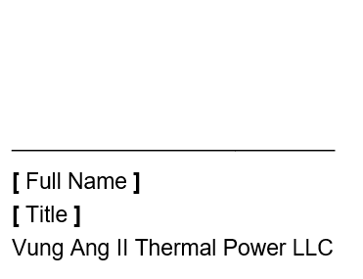

The text size must also be 12.

The signature section should provide ample space for signing and be separated by an underline. Below the line, the Sender's full name, position, and the full name of the Company should be recorded.

Decision

Date and Document Number

The date is displayed in the top right corner of the document in the format "Date Month Year".

Below the date, a designated Document Number, following 2.1.1 of ANNEX 2, is displayed in bold, size 12, right aligned.

Title and Subject

As the subject of the decision, "XXXX's Decision" is written in bold, size 16, and center aligned.

Under this, the subject of the decision is presented in the format "(Re: XXXXXXXXXXXXXXXXXXXXXXXXXX)" in size 12, italicized.

Main Body

The main body of the decision follows a hierarchical structure using L1 14 ANNEX, L2 12 ANNEX, L5 12 Body Text, and L6 12 Bullet in Styles.

Power of Attorney (POA)

Header, Footer, Logo and Address

The header, footer, logo, and address of the POA follow the same format as the Outgoing Correspondence.

Date and Document Number

The date and Document number of the POA follow the same format as the Decision template.

Subject

As the subject of the POA, “POWER OF ATTORNEY” is written in bold, size 16, and center aligned.

Assigner and Assignee Information

The full name, position, and address of the Assigner and the full name, position, and address of the Assignee must be presented in order, left-aligned, and in size 12, by hidden table as shown below.

|  |  |  |  |
| --- | --- | --- | --- |
| **General Director and Legal Representative – Assigner:** | | | |
|  | Full name | : | XXXXXXXXXXX |
|  | Position | : | General Director and Legal Representative of Vung Ang II Thermal Power LLC (“***VAPCO***”) |
|  | Address | : | Room 3011, 30th Floor, West Tower, Lotte Building,  54 Lieu Giai, Ba Dinh, Hanoi, Vietnam |
| **XXXXXXXXXXXXXXXXXXXXXXXXXXXXXXX – Assignee:** | | | |
|  | Full name | : | XXXXXXXXX |
|  | Position | : | XXXXXXXXXXXXXXXXXXXXXXXXXXXXX of Vung Ang II Thermal Power LLC (“***VAPCO***”) |
|  | Address | : | Vung Ang II Thermal Power Project Office,  Ky Loi commune, Ky Anh town, Ha Tinh province, Vietnam |

Scope of Authorization

Below the Assigner and Assignee Information, “Scope of Authorization:” should be shown in size 12, bold.

The main body of the POA follows a hierarchical structure using L1 14 ANNEX, L2 12 ANNEX, L5 12 Body Text, and L6 12 Bullet in Styles.

Duration for Authorization

Unless otherwise specified, “Except for the revocation, the Power of Attorney shall become effective from XX XX XXXX until canceled by either party in writing.” should be shown.

Signatory

The signatory must be provided in bold, size 12 by hidden table.

|  |  |
| --- | --- |
| **Assigner** | **Assignee** |
|  |  |
| **Go Fukushima** | **XXXXXXXXXXXX** |
| **General Director** | **XXXXXXXXXXXX** |

Other Templates

Document templates not listed above, which do not require internal or external publication and are simple approval-related templates, will be developed directly within EADMS without a designated format.

COMPANY SEAL

Seal Management

The authorized personnel is responsible for assigning the PIC for handling and utilizing the seal.

The designated individual responsible for seal preservation shall:

* Safely preserve and use the Company's seal and secret key storage device, with the key/password held by the PIC.
* Assign the Company's seal to others only with prior approval from the authorized personnel. The handover of the Company’s seal and secret key storage device must be meticulously recorded in writing and controlled by the PIC.
* Directly affix the Company’s seal to Documents issued under the authorized personnel and duplicates of Documents.
* Ensure that the Company's seal is affixed only to Documents signed by an authorized person and copies of Documents directly executed by the Company.
* Be responsible for securely preserving the device storing the private key and secret key.

Seal Using

Seal Specification

The Company employs a single round seal inscribed with the name "Công ty TNHH Nhiệt điện Vũng Áng II".

Approval of Seal Usage

To ensure the legal effectiveness of the Company Seal, prior approval for its use must be obtained through the Internal Approval process in the EADMS.

Stamping Requirements

* The stamp must be clear, neat, properly aligned, and use the correct red stamp ink in compliance with regulations.
* When stamping a signature, the stamp must cover approximately one-third (1/3) of the signature to the left.
* For Documents issued with main Documents or annexes, the seal must be affixed to the first page, covering part of the name of the agency, organization, or annex title.

Special Stamp Application

* The use of hanging stamps, overlapping stamps, and embossed stamps on paper Documents shall be subject to the prescription of the head of the agency or organization.
* The border stamp must be placed in the middle of the right edge of the Document or Document appendix, covering part of the pages
* Each stamp may secure a maximum of five (05) pages.

Storage and Security

When not in use, the Company seal must be securely stored in a safe.

# DOCUMENT MANAGEMENT

CONFIDENTIAL DOCUMENT

### Classification

* The Manager of the relevant Department or higher may classify an Internal Document or Correspondence as Confidential and designate authorized personnel who are permitted to access the Document during the review and approval or distribution processes through EADMS.
* If a Document is classified as a Confidential Document and generated by the Company, the Document preparer shall mark "CONFIDENTIAL" in bold, size 16, with a red border of 1 1/2 pt width and dimensions of 1 cm x 4 cm on the upper right corner of each page.
* If a Document is classified as a Confidential Document and originated from outside, the PIC in the relevant Department shall stamp “CONFIDENTIAL” on the upper right corner of each page before submitting it to DC for storage.

Access Control

Only the DC and authorized personnel may access Confidential Documents based on need-to-know and approval-based access control shall be allowed to reproduce copies depending on the intended party’s instruction.

Storage and Protection

Physical Documents

* Must be stored in locked cabinets or safes in DSR with limited access.
* Access logs must be maintained for sensitive Document handling.

Electronic Documents

* Must be stored in encrypted, access-controlled server.
* Two-factor authentication (password and key) must be enabled for access.

Retrieving and Borrowing

Confidential Documents must not be shared via unsecured channels (e.g., personal email, USB, public cloud storage).

When emailing Confidential Documents, using encryption and password-protected attachment is recommendable.

External sharing requires written approval from the Manager of the relevant Department or higher.

Disposal and Destruction

Physical Document

Must be shredded or incinerated when no longer needed.

Electronic Document

Must be permanently deleted using secure deletion software. Backup copies must be destroyed following the data retention Procedure.

NON-CONFIDENTIAL DOCUMENT

Classification

In accordance with Clause 3.1.1 of this Procedure, all Documents that are not classified as Confidential Documents shall be considered Non-Confidential Documents. This includes Incoming/Outgoing Correspondence, as well as Internal Documents such as Technical Documents and others.

All received or recorded Documents shall be marked or stamped as “MASTER COPY” or “WORKING COPY” by using the red stamp. Only authorized person can borrow the master copies of Documents.

* Master Copy – Documents that are stored and maintained in the filing cabinet, which most of the time are original and officially received copies.
* Duplicate Copy – Documents that are for general use.

All original Documents shall be red marked or stamped as “ORIGINAL COPY” on the lower corner on the front page of the original Documents.

Receiving and Distribution/ Recording and Dispatch

Receiving and Distribution of Incoming Correspondence

* Receiving

The DC and PIC of each Department/Division shall receive and log all Incoming Correspondences in Master Receiving Log in EADMS for control log number for recording purposes prior to dissemination of the Documents to the respective Director or higher.

* Distribution

The Directors or higher who receive the Incoming Correspondences will review and forward all the stamped Documents to the responsible Department or PIC classifying them following the criteria below through EADMS.

**Based on Required Action**

|  |  |
| --- | --- |
| **Classification** | **Description** |
| Action | Documents requiring specific actions by a Department or responsible personnel. |
| Information | Documents shared for reference only, with no required action. |
| Approval Required | Documents that require approval from higher management or relevant departments. |
| Review | Documents that need to be reviewed and require feedback. |

**Based on Document Type**

|  |  |
| --- | --- |
| **Classification** | **Description** |
| Contractual | Documents related to contracts, purchase orders, procurement documents, and other contractual agreements. |
| Technical | Documents such as drawings, specifications, reports, and design change requests. |
| Legal & Compliance | Legal contracts, regulatory requirements, and audit-related Documents. |
| Financial | Invoices, payment requests, budget reports, and other financial Documents. |

**Based on Priority**

|  |  |
| --- | --- |
| **Classification** | **Description** |
| Urgent | Documents requiring immediate action within one (01) day of acknowledgement. |
| Normal | Documents that must be processed within a designated timeframe, normally within three(03) days acknowledgement. |
| Low Priority | Documents kept for long-term reference or record-keeping purposes within five (05) days acknowledgement. |

Upon the acknowledgement of the relevant Department, the Document Number shall be automatically generated and assigned following the principle set out in 2.1 of ANNEX 1. The original Documents will be stored in the DSR for filing and maintenance (if any).

If the acknowledgement from the respective Department is not received after the priority due date, EADMS will automatically send a notification to the Department regarding the overdue deadline.

Recording and Dispatching of Outgoing Correspondence and Internal Documents

* In case of external Outgoing Correspondence, upon the Sender's approval via EADMS, the Document Number is automatically generated and assigned following the principle set out in 1.1 of ANNEX 1. All Outgoing Correspondences shall be properly logged in the Master Outgoing Log in EADMS.
* Upon the authorized person’s approval on Internal Documents, all internal Correspondences between the Department/Division and Internal Documents shall be properly logged in the EADMS and assigned a Document Number following the principle set out in 2.1.1 of ANNEX 2 prior to turn-over or finalization.
* If the original copy of Document has to be sent outside the Company, the assigned personnel shall fill-up the Transmittal Form in EADMS and submit the original Document to DC. The DC shall be responsible in preparing the airway bill or domestic ticket for dispatching of the Documents.
* If the document is to be sent by fax, the PIC shall submit the original Document to DC and register Fax Tranmittal Sheet through EADMS attaching the fax confirmation report. The PIC is also required to follow-up by phone call if the fax was received.
* For Documents with many recipients, all receiving acknowledgment, fax confirmation report and DHL details shall only be in one receiving copy.

Storage

All Documents shall be categorized, filed and stored to their respective folder by organization and Document type with assigned File/Folder Numbering attached hereto as ANNEX 2.

Physical Documents

* The original Documents (if any) shall be classified and stored in DSR according to the Document Number.
* Access logs shall be maintained in EADMS through the borrowing slip.

Electronic Documents

* The electronic Documents hsall be classified and stored in EADMS when they are properly approved and registered.
* The Documents that require general publication within the Company or are frequently used may be stored on the Common Server.

Retrieving and Borrowing

Only working copy or duplicate copy of Documents can be borrowed from the DSR. All Documents going out from the DSR shall be properly registered by the DC.

Documents can be retrieved on the computer with their electronic file through Documents Number, date of Documents and subject that are also included on the File/Folder Number where the specified Documents are stored.

Borrowing original Documents and master copies is discouraged, except in exceptional case. The purpose of borrowing and using those Documents shall be for the sole interest of the Company. The borrower shall seek approval from the Manager of the owner Department before requesting DC to check out the Document.

Only working copy of the Documents can be borrowed from the DSR. The borrower will fill-up the borrowing slip in EADMS. Searching for the Documents to be borrowed is the responsibility of the borrower with the assistance of the DC. Documents shall be retrieved according to their respective discipline. Documents.

Disposal and Destruction

Physical Document

Must be shredded or incinerated when no longer needed.

Electronic Document

Must be permanently deleted using secure deletion software. Backup copies must be destroyed following the data retention Procedure.

**ANNEX TO THIS PROCEDURE**

|  |  |
| --- | --- |
| **NO.** | **DESCRIPTION** |
| ANNEX 1 | CORRESPONDENCE NUMBER CODING |
| ANNEX 2 | INTERNAL DOCUMENT NUMBER / FILE NAME CODING |
| ANNEX 3 | TEMPLATES |
| ANNEX 4 | ABBREVIATION OF O&M OFFICE |

[ANNEX 1] CORRESPONDENCE NUMBER CODING

1. Outgoing Correspondence
   1. Structure of Coding

* 1. Receiving Entity Code

|  |  |  |  |  |
| --- | --- | --- | --- | --- |
| **CODE** | **DESCRIPTION** |  | **CODE** | **DESCRIPTION** |
| 3T | 3T Consulant and Investment Company |  | KPMG | Klynveld Peat Marwick Goerdeler Company Limited |
| BAMBOO | Bamboo Airlines |  | KRE | Korean Embassy in Vietnam |
| BAYAN | PT Bayan Resources Tbk. |  | KTPC | Peoeple's Committee of Ky Thinh ward |
| BIDV | Bank for Investment and Development of Vietnam |  | KTPC | People's Committee of Ky Thinh ward |
| BMTB | BMTB Construction Design and Trading Company Limited |  | Kwang Jin | Kwangjin Machiner company |
| CHUGOKU | Chugoku Electric Power CO., INC. |  | KYC | KYC Machine Industry Vietnam Co., Ltd |
| COBELFRET | CLdN Cobelfret S.A (Shipping company) |  | LCSR | Land Compensation Support and Resettlement Council of Ky Anh town |
| CPMB | Central Vietnam Power Projects Management Board |  | LRV | Long River Engineering Company Limited |
| CSR | Corporate Social Responsibility (CSR related letters) |  | LUNGLO | Lung Lo Construction Company |
| DELOITTE | DELOITTE Vietnam Company |  | MC | Member Council |
| DGA | Diamond Generating Asia Limited |  | MIZUHO | Mizuho Bank Ltd |
| DOET | Department of Education and Training of Ha Tinh province |  | MJ | MJ Logistic Company |
| DOF | Department of Finance of Ha Tinh province |  | MOC | Ministry of Construction |
| DOH | Department of Health of Ha Tinh province |  | MOCST | Ministry of Culture, Sports and Tourism |
| DOIT | Department of Industry and Trade of Ha Tinh province |  | MOD | Ministry of National Defense |
| DOLISA | Department of Labour, War Invalids and Social Affairs of Ha Tinh province |  | MOF | Ministry of Finance |
| DONRE | Department of Natural Resources and Environment of Ha Tinh province |  | MOIT | Ministry of Industry and Trade |
| DOT | Department of Transport of Ha Tinh province |  | MOLISA | MINISTRY OF LABOUR – INVALIDS AND SOCIAL AFFAIRS |
| DPI | Department of Planning and Investment of Ha Tinh province |  | MONRE | Ministry of Natural Resources and Environment |
| DT | Duc Toan company (bidding company) |  | MOST | Ministry of Science and Technology |
| EOI | Embassy of India |  | MOT | Ministry of Transport |
| EPCJV | Joint Venture of Doosan - Samsung |  | MUFG | Mitsubishi UFJ Financial Group Bank |
| EPCLO | Pacific Corporation (Local EPC) |  | NBNS | National Bidding Network System |
| EPTC | Electric Power Trading Company |  | NO | Notarization Office |
| EPTC | Electricity Power Trading Company |  | NS2PC | Nghi Son 2 Power Limited Liability Company |
| EREA | Electricity and Renewabe Energy Authority |  | NSMO | National Power System and Market Operator Company Limited |
| EVN | Vietnam Electricity Group |  | NSMO | National Power System and Market Operator Company (previously EVNNLDC) |
| EVNICT | Information and Communications Technology Company of EVN |  | NSO | Branch of National Power System and Market Operator Company Limited - Northern Power system Dispatch Center |
| EVNNLDC | National Load Disptach Center (previous name of NSMO) |  | OGL | Outgoing General Letters |
| EVNNPT | National Power Transmission Corporation |  | PCHT | Ha Tinh Power Transmission Company |
| EVNNRLDC | Northern Region Load Dispatch Center of Electricity of Vietnam |  | PECC1 | Power Engineering Consulting Joint Stock Company 1 |
| EY | Ernst & Young Global Limited |  | PM | Prime Minister |
| FRPD | Police Department of Fire Prevention and Fighting and Rescue of Vietnam - Ministry of Public Security |  | PS | Potential Suppliers (Bidding) |
| GO | Government Office |  | PTC1 | Power Transmission Company No.1 |
| HEZA | Ha Tinh Economic Zone Authority |  | PTC2 | Power Transmission Company No.2 |
| HID | Hatinh Immigration department |  | PTECH | PTech Company Limited |
| HQVA | Vung Ang Custom Department |  | PVI | PVI Insurance Corporation |
| HTFRPD | Police Department of Fire Prevention, Fighting and Rescue of Ha Tinh province |  | PVN | Vietnam Oil and Gas Group (PetroVietnam) |
| HTHQ | Customs Department of Ha Tinh |  | PVPHT | Petrovietnam Power Ha Tinh company (VA1) |
| HTNA | Ha Tinh National Assembly Delegation Team |  | PVPOWER | PetroVietnam Power Coporation |
| HTPA | Ha Tinh Port Authority |  | PWC | PricewaterhouseCoopers International Limited |
| HTPC | People's Committee of Ha Tinh province |  | RMZ2 | Road Management Zone 2 |
| HTPCc | People's Council of Ha Tinh province |  | SAS | Melia Hanoi hotel |
| HTPOLICE | Ha Tinh province Police |  | SBV | State Bank of Vietnam |
| HTTAX | Ha Tinh province Tax Department |  | SIC | State Inspection Council |
| HTTV | Ha Tinh Television |  | SMBC | Sumitomo Mitsui Banking Corporation |
| HTWS | Ha Tinh Water Supply |  | SMTB | Sumitomo Mitsui Trust Bank |
| IGL | Incoming General Letters |  | STAMEQ | Directorate of Standards, Metrology and Quality |
| IMC | IMC Shipping Co.Pte.Ltd. (Shipping company) |  | TCT | General Department of Taxation |
| JBIC | Japan Bank for International Cooperation |  | TEPSCO | Tokyo Electric Power Services Co., Ltd |
| KAAUTHORITIES | Ky Anh town's authorities (in general) |  | TT | T&T Joint Stock Company |
| KAPC | People's Committee of Ky Anh town |  | VABG | Vung Ang - Son Duong Border Guard Command Board |
| KAPOLICE | Ky Anh town police |  | VAFIE | Vietnam's Association of Foreign Invested Enteprises |
| KATAX | Ky Anh town Tax Department |  | VAPOLICE | Vung Ang Economic Zone Police Station |
| KAWS | Ky Anh town Branch Water Supply |  | VASI | Vietnam Administration of Seas and Islands |
| KEPCO | Korea Electric Power Corporation |  | VASub | 500kV Vung Ang Substation |
| KEXIM | Export–Import Bank of Korea |  | VID | Vietnam Immigration Department |
| KLFA | Ky Loi Farmer Association |  | VIETINBANK | Vietnam Joint Stock Commercial Bank for Industry and Trade |
| KLGPC | Peoeple's Committee of Ky Long ward |  | VLP | Viet - Lao International Port JSC |
| KLPC | Peoeple's Committee of Ky Loi commune |  | VMS-North | Northern Vietnam Maritime Safety Corporation |
| KLPC | Peple's Committee of Ky Loi commune |  | VNMA | Vietnam Maritime Administration |
| KLPC POLICE | Police Station of Ky Loi commune |  | VPBANK | Vietnam Prosperity Joint Stock Commercial Bank |
| KOE | Korea Engineering & Power Service Co., LTD |  | YANCOAL | Yancoal Australia Sales Pty Ltd |

* As the number of external recipients increases, this table will also be updated.

1. Incoming Correspondence
   1. Structure of Coding

# 

* 1. Receiving Organization Code

|  |  |  |  |  |
| --- | --- | --- | --- | --- |
| **CODE** | **DESCRIPTION** |  | **CODE** | **DESCRIPTION** |
| **HO** | **Hanoi Office** |  | **PO** | **Plant Office** |
| GD | General Director |  | SGM | Station General Manager |
| CFO | Chief Finance Officer |  | HSE | HSSE Department |
| AF | Accounting & Finance Department |  | GAC | GA & Contract Department |
| FN | Finance Department |  | OD | Operation Director or Division |
| AD | Administrative Director |  | OP | Operation Department |
| HR | HR Department |  | CF | Chemical/Fuel Department |
| AD | Administration Department |  | MD | Maintenance Director or Division |
|  |  |  | BLR | Boiler Department |
|  |  |  | TBN | Turbine Department |
|  |  |  | EL | Electrical Department |
|  |  |  | IC | I&C Department |

[ANNEX 2] INTERNAL DOCUMENT NUMBER / FILE NAME CODING

1. Document Number Coding
   1. **Document Number Structure**

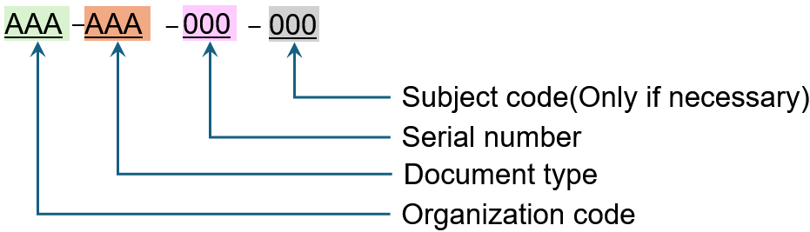

The length of the serial number may be extended based on the type or classification of the document.

* 1. **Organization Code: Refer to 1.2 of ANNEX 1**
  2. **Document Type**

|  |  |  |  |  |
| --- | --- | --- | --- | --- |
| **TYPE** | **DESCRIPTION** |  | **TYPE** | **DESCRIPTION** |
| APP | Application software |  | INS | Instructions/Manual |
| AUD | Audit |  | JD | Job Description |
| BLU | Blueprint Diagram |  | JHA | Job Hazard Analysis |
| BP | Business Plan |  | LOG | Logistic |
| BTP | Berthing Procedure |  | MDR | Manufacturer data Records |
| BUD | Budget |  | MNU | Manual |
| CLP | Coal Procedure |  | MOM | Minutes |
| CFG | Configuration software |  | MPL | Plan |
| CMP | Commissioning plan |  | PRP | Procuremen Plan |
| CMR | Commissioning report |  | PUR | Purchase Order |
| CMT | Commitment |  | ORG | Organizational Chart |
| CON | Contract |  | OTH | Others |
| CRP | Correspondence |  | PFD | Process Flow Diagram |
| DES | Design Calculations |  | PFD | Process Flow Diagram |
| DRW | Drawing |  | REC | Record |
| EDS | Equipment Data Sheet |  | REG | Register, List or Table |
| ERF | Expenditure Request Form |  | REP | Report |
| EMR | Emergency Matertial Request |  | RSK | Risk Assessment |
| EQL | Equipment List |  | RUL | Rules or protocols |
| FOR | Form or Checklist and Template |  | SCH | Schedule |
| FUS | Functional specification |  | SOP | Standard Operating Procedure |
| GIS | Goods Issuance Slip |  | SOW | Scope of work |
| GRN | Goods Receipt Note |  | SPE | Specification for design/ performance |
| GUD | Guideline |  | STD | Standard |
| HM | Handover Minutes |  | TRA | Training Assessment |
| ICC | Inventory Cycle Count |  | TRM | Training Module |
| INF | Information Sheet |  | WMS | Work Method Statement |

* As the number of Document types increases, this table will also be updated.

** For those that have not been mentioned in table above, “Others – OTH” should be used or depending on the Documents feature, the department should define the prefixes and obtain approval.

* 1. **Subject Code**

|  |  |  |  |  |
| --- | --- | --- | --- | --- |
| **CODE** | **DESCRIPTION** |  | **CODE** | **DESCRIPTION** |
| **100** | **Project General** |  | **500** | **Contract & Procurement** |
| 110 | Project Management Procedure, Procedure & Guideline |  | 510 | Sourcing/Surveillance of Potential Suppliers |
| 120 | Public & External Relations |  | 520 | Issuance of Procurement Specification, Invitation to Bid, Request for Proposal and Change Order Request |
| 130 | Consents, Permits & Licenses |  | 530 | Supplier's Qualifications |
| 140 | Organization |  | 540 | Quotations, Negotiations |
| 150 | Power Purchase Agreement (PPA) |  | 550 | Issuance of Authorization to Proceeds, Contracts & Purchase Orders/Amendments, etc. |
| 160 | Engineering, Procurement & Construction (EPC) |  | 560 | Engagement of Legal, Financial & Technical Advisory Services |
| 170 | Operation & Maintenance (O&M) |  | 570 | Logistics, Forwarding & Transportation |
| 180 | Technical Services Agreement |  | 580 | Project Insurance |
| 190 | Coal Sales Agreement (CSA), Coal Transportation Agreement (CTA), etc. |  | 590 | Others |
| **200** | **Administration** |  | **600** | **Material Management** |
| 210 | Correspondence, Document & Data Record Management |  | 610 | Inventory Control |
| 220 | Security & Confidentiality Control |  | 620 | Material Requisition or Purchase Requisition |
| 230 | Wages, Fringe Benefits & Compensations |  | 630 | Customs Clearance, Import Permit & License |
| 240 | Employment & Labor Relations |  | 640 | Inspection & Report on Material Receiving |
| 250 | Research & Development, OJT and Other Training |  | 650 | Material Return, Shipping Notice/Re-Export Notice (Onshore/Offshore) |
| 260 | Housekeeping, Sanitary & Cleaning |  | 660 | Claims & Back-charge by Overage, Shortage & Unsatisfactory Report, Document Deficiencies, etc. |
| 270 | Litigation – Proceedings and Administration |  | 670 | Management of Warehouse & Lay-down Area |
| 280 | Office Supplies and Consumables |  | 680 | Labor, Equipment, Tools & Instruments for Material Control |
| 290 | Ceremony, Protocols & others |  | 690 | Others |
| **300** | **Planning & Control** |  | **700** | **Construction** |
| 310 | Management Procedure & Instructions |  | 710 | Basic Planning, Design & Engineering |
| 320 | Codes, Standards, Regulations & Ethics |  | 720 | Quality Assurance & Control (Audit Findings, Non-Conformance Reports) |
| 330 | Meetings of Stockholders, Board of Directors, etc. |  | 730 | Cost & Schedule Control |
| 340 | Planning, Budget & Cost Control |  | 740 | Construction Supervision |
| 350 | Audit Findings |  | 750 | Shop Inspection (Offshore/Onshore) & Field Surveillance |
| 360 | Safety Management |  | 760 | Work Orders |
| 370 | Petition & Resolution |  | 770 | Review and Report for Project Progress (Steering Committee/PRM) |
| **400** | **Finance & Account** |  | 780 | Start-up & Commissioning Tests (Performance/Reliability/Guarantee/Acceptance) & Reports |
| 410 | General Accounting |  | **800** | **Operation & Maintenance** |
| 420 | Fiscal Planning & Operations |  | 810 | Planning for Operations & Maintenance |
| 430 | Cash Flow Management |  | 811 | Standard Operational Procedures |
| 440 | Tax, Stamp, Registration, etc. |  | 820 | Planning for Demand & Requisition of Fuel |
| 450 | Financial Statement & Balancing |  | 830 | Control of House Load & Efficiency, In-service Tests etc. |
| 460 | Debt Financing & Loan Agreement |  | 840 | Dispatch Instructions & Load Control |
| 470 | Shareholder's Agreement, Equity & Stock Management, Listing etc. |  | 850 | Outage Report & Remedial Activities |
| 480 | Computation for Availability Fees, Fixed O&M Fees, Energy Fees etc., Billing & Payment. |  | 860 | Repair & Maintenance Request |
| 490 | Others |  | 870 | Emergency Response Activities |
|  |  |  | 880 | Record of Electricity Measurement & Reporting |
|  |  |  | 890 | Administration of Environmental Compliance |

1. File Name Coding
   1. General Principle

* All file names must be in English.
* All file names must be clear and consistent to ensure easy identification.
* Each word in the file name should be capitalized.
* Do not use special characters or symbols in file names, including but not limited to: * ? ~ \ | / < > ^ @ ! ; , ‘ “ ” + ) (
  1. File Name Structure

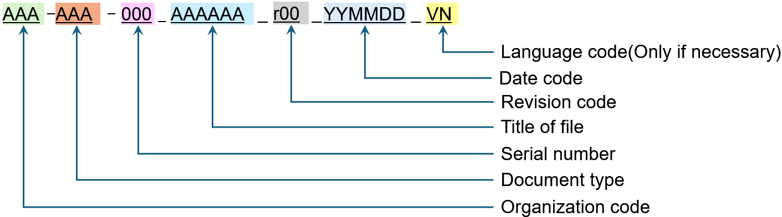

* 1. Organization Code: Refer to 1.2 of ANNEX 1
  2. Document Type: Refer to 1.3 of ANNEX 2
  3. Language Code
* EN: English
* VN: Vietnamese

The Company’s business language is English. Therefore, in all Documents, usage of English is encouraged and, if there is any discrepancy, English prevails Vietnamese.

[ANNEX 3] TEMPLATES

* New templates will be developed as needed and will be updated here.

1. Operational Documents (Guideline, Procedure, Regulation, etc.)

*U:\1000_Common use\03_Procedure & Regulations\12. Operational documents*

1. Outgoing Correspondence

*U:\1000_Common use\03_Procedure & Regulations\13. Template for Doc Procedure*

1. Decision

*U:\1000_Common use\03_Procedure & Regulations\13. Template for Doc Procedure*

1. Power of Attorney

*U:\1000_Common use\03_Procedure & Regulations\13. Template for Doc Procedure*

[ANNEX 4] ABBREVIATION OF O&M OFFICE

* The abbreviation of the O&M Office is arranged based on the organizational chart.

|  |  |  |  |  |
| --- | --- | --- | --- | --- |
| **ABBREVIATION** | **DESCRIPTION** |  | **ABBREVIATION** | **DESCRIPTION** |
|  | **Location/ Position** |  | OSL | Operation Shift Leader |
| OMO | O&M Office |  | CRO | Control Room Operator (BLR, TBN) |
| PO | Plant Office |  | ACRO | Assitant CRO (ACRO) |
| OMA | O&M Accommodation |  | FOBT | Field Operator (BLR, TBN) |
| DRT | Director |  | EAFO | EP/ Ash/ FGD Operator |
| MGR | Manager |  | FOEAF | Field Operator (EP/ ASH/ FGD) |
| TL | Team Leader |  | **CF** | **Chemical/ Fuel Department** |
| SUP | Supervisor |  | CFM | Chemical/ Fuel Manager |
| SPE | Specialist |  | CFL | Chemical/ Fuel Leader |
| ENGR | Engineer |  | CFS | Chemical/ Fuel Supervisor |
| TECH | Technician |  | CFE | Chemical/ Fuel Engineer |
| ASST | Assistant |  | CFT | Chemical/ Fuel Technician (LAB) |
| DEPT | Department |  | WTO | CPP/ Demi Water, WWT Operator |
| **SGM** | **Station General Manager** |  | CHSS | Coal Handling Shift Supervisor |
| PD | Plant Director (Project Director) |  | CHCRO | Coal Handling Control Room Operator (ST/ RE, Line) |
| STA | Admin Assistant (Traffic) & Secretary |  | CHFO | Coal Handling Field Operator (Ship Unloader, ST/ RE, Line, Tripper) |
| **HSE** | **HSSE Department** |  | HEO | Heavy Equipment Operator |
| HSEM | HSSE Manager |  | **MD** | **Maintenance Division** |
| FSS | Fire & Safety Supervisor |  | MD | Maintenance Division Director |
| FSE | Fire & Safety Engineer |  | **BLR** | **Boiler Department** |
| FST | Fire & Safety Technician |  | BLRM | Boiler Manager |
| DCT | Doctor |  | BLRL | Boiler Leader |
| NRS | Nurse |  | BLRS | Boiler Supervisor |
| SCS | Security Supervisor |  | BLRE | Boiler Engineer |
| QCE | QC Engineer |  | BLRT | Boiler Technician |
| ENE | Environmental Engineer |  | MCHL | Maintenance Coal Handling Leader |
| **GAC** | **GA & Contract Department** |  | MCHS | Maintenance Coal Handling Supervisor |
| GACM | GA & Contract Manager |  | MCHE | Maintenance Coal Handling Engineer |
| GPL | GA & Personnel Leader |  | MCHT | Maintenance Coal Handling Technician |
| HRA | Admin Assistant (HR) |  | WSS | Workshop Supervisor |
| HIA | Admin Assistant (Housekeeping) & Interpreter |  | WSW | Workshop Welder |
| CVE | Civil Engineer |  | WSM | Workshop Machinist |
| CHA | Admin Assistant (Canteen/ Housing) |  | MEO | Mobile Equipment Operator |
| ACT | Accountant |  | MET | Mobile Equipment Technician |
| ITS | IT Supervisor |  | **TBN** | **Turbine Department** |
| ITA | IT & Admin Asssitant (Document Controller) |  | TBNM | Turbine Manager |
| WHS | Warehouse Supervisor |  | TBNDM | Turbine Deputy Manager |
| WHA | Warehouse Assistant |  | TBNL | Turbine Leader |
| PCRS | Public Relations & Community Relations Supervisor |  | TBNS | Turbine Supervisor |
| PCRA | Public Relations & Community Relations Assistant |  | TBNE | Turbine Engineer |
| PCL | Procurement & Contract Leader |  | TBNT | Turbine Technician |
| PCS | Procurement & Contract Specialist |  | CME | Condition Monitoring Engineer |
| PCA | Procurement & Contract Assistant |  | **EL** | **Electrical Department** |
| CLL | Coal Logistics Team Leader |  | ELM | Electrical Manager |
| CLS | Coal Logistics Specialist |  | ELL | Electrical Leader |
| CLA | Coal Logistics Assistant |  | ELS | Electrical Supervisor |
| **OD** | **Operation Division** |  | ELE | Electrical Engineer |
| OD | Operation Division Director |  | ELT | Electrical Technician |
| **OP** | **Operation Department** |  | **IC** | **I&C Department** |
| OPM | Operation Manager |  | ICM | I&C Manager |
| PPL | Power Production Leader |  | ICL | I&C Leader |
| PPS | Power Production Supervisor |  | ICS | I&C Supervisor |
| PPE | Power Production Engineer |  | ICE | I&C Engineer |
| PPT | Power Production Technician |  | ICT | I&C Technician |